Lab exercises 4: Selection Name: ____________________________
Exercise 1: Evaluate the conditions
Focus: relational operators, logical operators, and precedence.
int x = 8, y = 3, z = 8;
bool ready = false;

Complete the table without running a program. Write both the Boolean result and its numeric value (0 or 1).
 | Expression | true / false | 0 / 1
a | x > y | True | 1
b | x != z | false | 0
c | (y >= 1) && (y <= 5) | true | 1
d | (x < y) || (z == 8) | true | 1
e | !ready | true | 1
f | (x < y) || (z == 8) && (y > 5) | false | 0
(g) Explain which logical operator is evaluated first in (f).

False||( true && false) = False

Exercise 2: Trace independent if statements
Focus: execution order and statements outside the if body.
Assume the following code is inside main().
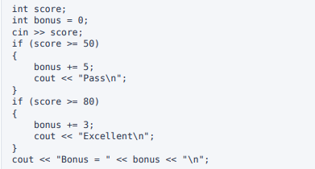
- Write the exact output for each input: 49, 50, 79, and 80.
49 =49 bonus 0 = 49
50= Pass 50 bonus 5 = 55
79= Pass 79 bonus 5 = 84
80= Excellent 80 bonus 8 = 88

- For an input of 80, how many if bodies execute? Explain why.
2 bodies execute .The two if are separate,80 fit both condition of if.

- Does the final cout statement execute when the input is 49? Explain.
Yes, because the final cout is outside of if statement.it will be print out no matter the input.for 49 the print will be Bonus = 0.

Exercise 3: Find and fix the logic errors
Focus: semicolons, equality, braces, and numeric ranges.

Each snippet is inside main(). For each part, explain the error and rewrite the affected statements so they match the intended behaviour.
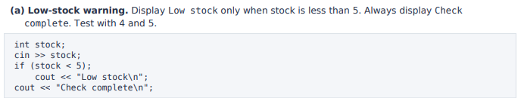
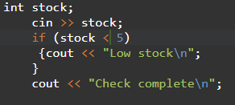
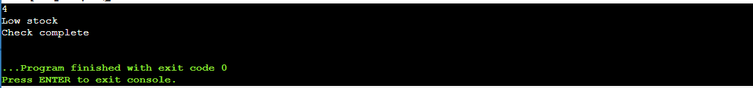

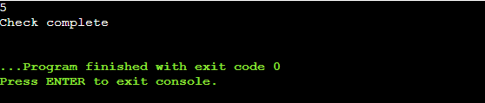

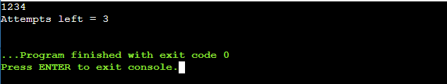
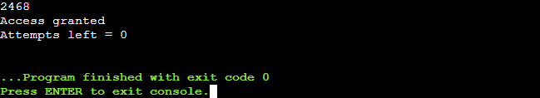
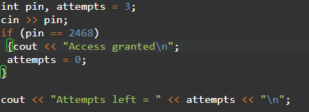
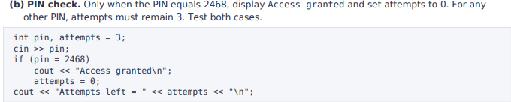

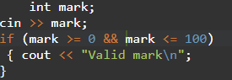
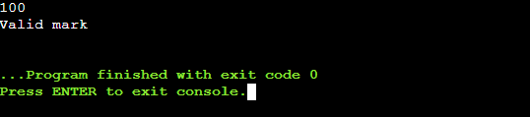
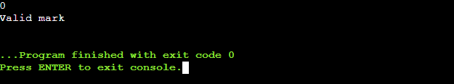
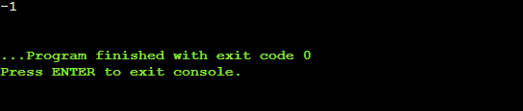
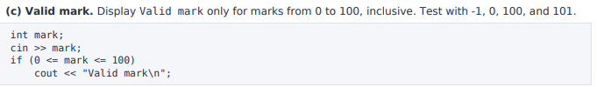
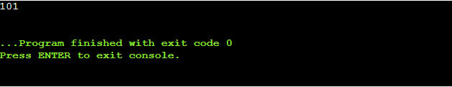

Exercise 4: Campus shop discount
Focus: initialise a value, then update it using one if statement

A campus shop gives a 10% discount when a purchase is RM100 or more. For a smaller purchase, the discount is RM0.00. Assume the purchase amount is a valid non-negative number
- Prepare pseudocode or a flowchart for the solution
START
READ purchase
SET discount = 0
IF purchase >= 100 THEN
discount = purchase * 0.10
END IF
havetopay = purchase - discount
DISPLAY discount, havetopay (2 decimal places)
END

- Write a C++ program that reads the purchase amount, initialises the discount to zero, and uses one if statement to calculate any discount.
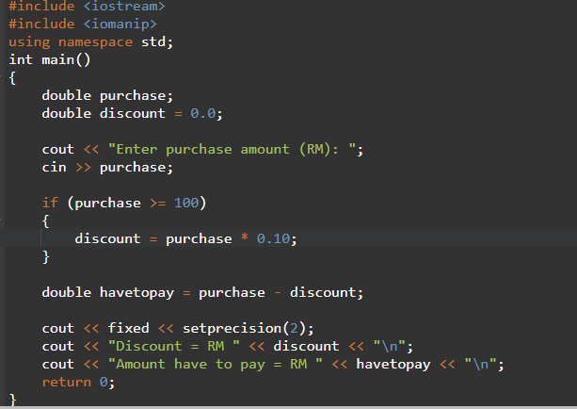

- Calculate and display the discount and final amount payable to two decimal places. Use <iomanip> for money formatting.
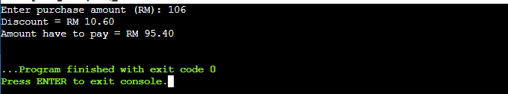
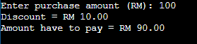
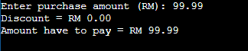
- Test your program with RM0.00, RM99.99, RM100.00, and RM150.00. Record the expected and actual results.
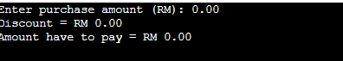
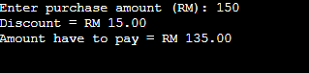

Exercise 5: Workshop eligibility checker
Focus: combine conditions with &&, store a bool, and use !.

A student can join a C++ workshop when both conditions are met: the student is at least 18 years old and has a prerequisite test mark of at least 60. Assume the age is non-negative and the mark is an integer from 0 to 100.
- Prepare pseudocode or a flowchart for the solution.
START
READ age, mark
eligible = (age >= 18) AND (mark >= 60)
IF eligible THEN
DISPLAY "Eligible for the workshop."
DISPLAY "Please complete the registration form."
END IF
IF NOT eligible THEN
DISPLAY "Not eligible for the workshop."
END IF
END

- Read the student's age and test mark. Declare a bool variable named eligible and assign it the result of a logical expression.
- Use if (eligible) to display both lines below in one body. Use braces.
Eligible for the workshop.
Please complete the registration form.
- Use a separate if (!eligible) statement to display Not eligible for the workshop.
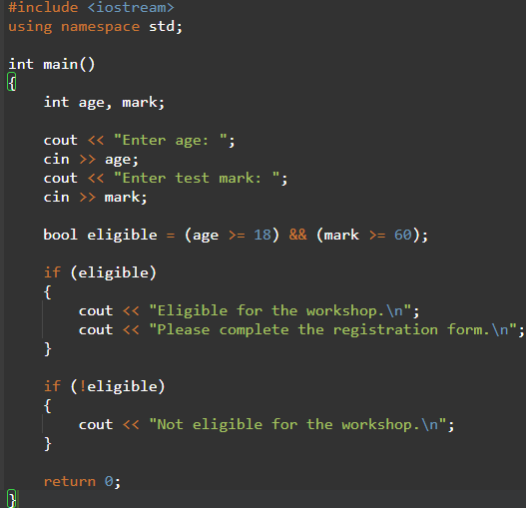

- Test all four combinations below. Record the output and state which condition prevents eligibility in each unsuccessful case.
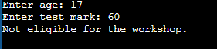
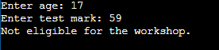
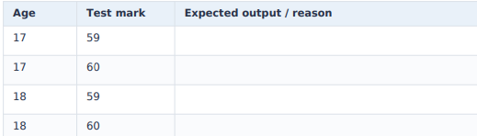

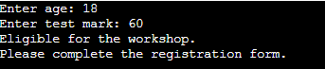
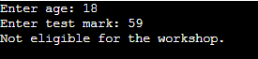

Exercise 6 | Optional: Monthly payment validator Optional
challenge: initialise a Boolean flag and guard division.

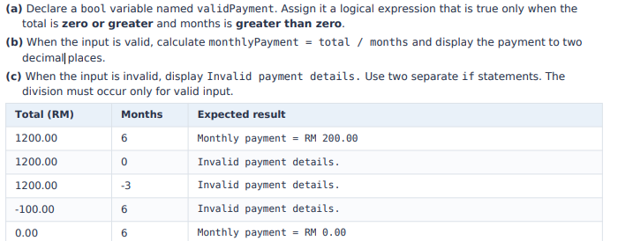
A shop lets customers divide a purchase into equal monthly payments, without interest. Write a C++ program that reads the total purchase amount and the number of months as a double and an integer, respectively.
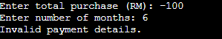
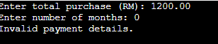
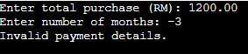
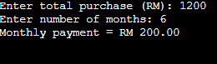
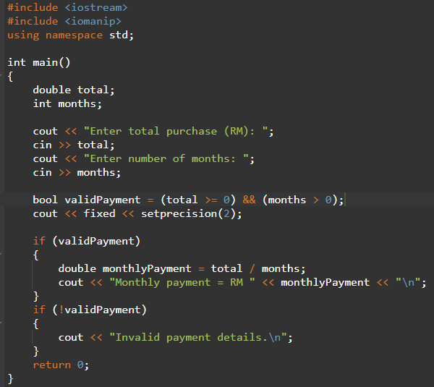
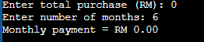

(f)Explain why zero months must be rejected before the calculation.
You can’t divide by zero, so the program has no valid answer when months is 0. Checking first means the division only runs when months > 0. Negative months are rejected too, because they make no sense for a payment plan.

